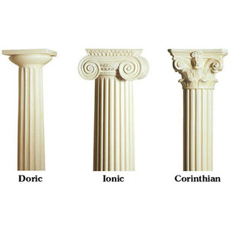Review Exam 1 Chapter 6

*Agriculture* (***Architecture*** xD)

Doric Columns (ex: Parthenon)  
Ionic Columns  
Corinthian Columns

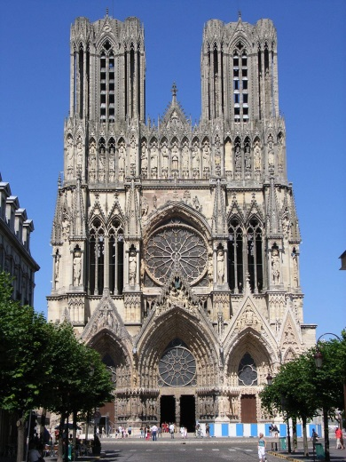

High- relief sculptures attached to buildings are considered Architecture*

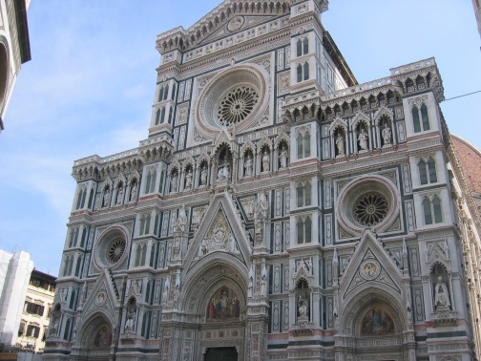

Notre dame (Right)  
Florence (Left)

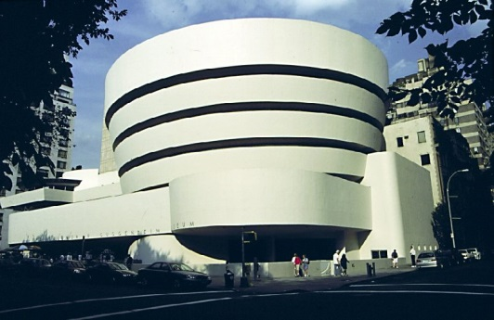

Form Follows Function! Think about the **Guggenheim**,  
spiral walkway, lighting from upper dome. Work done   
by **Frank Lloyd Wright**

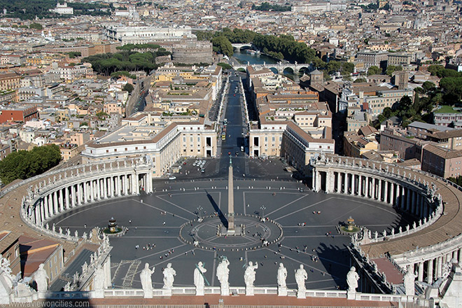**Architecture** is the shaping of buildings and space.  
**Centered Space** is the arrangement of things around some paramount thing, the place at which the other things seem to converge. Ex:

Four Necessities of Agriculture:

* 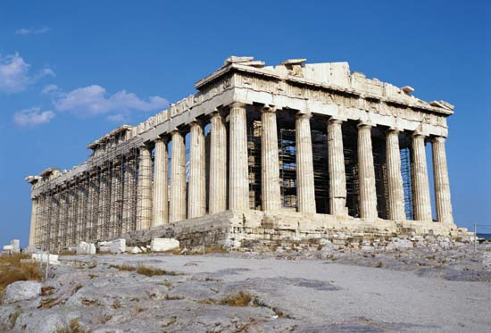technical requirements
* function
* spatial relationships
* revelatory requirements

*Technical requirement*: Ex: **post-and-lintel** (or beam) construction.   
Set on a base support the entablature (horizontals: the lintel)  
 which in turn, supports the **pediment** (the triangular structure) and roof.

*The columns bulge or swell slightly, a characteristic called **entasis**.

*Functional requirement*: (form follows function) Ex: The term **cantilever** refers to a structural principal in architecture in which one end of a horizontal form is fixed – usually in a wall – while the other end juts out over space.

**Earth-rooted** architecture accentuates this natural symbolism more than any other art. (Site, gravity, and raw materials)

Centrality

**Greek-cross** buildings, in which the floor plan resembles a cross whose arms are equal in length, are likely to center us in inner space more strongly than **Latin-cross** buildings, such as Chartres.

Sky-Oriented

Architecture that is **sky-oriented** suggests or is symbolic of a world as the generating agency that enables us to project our possibilities and realize some of them.

Earth-Oriented

**Earth-resting** buildings relate more or less harmoniously to the earth. Hm, what a great definition…  
**Earth-dominating** buildings do not sit on but “rule over” the earth.

Other Architecture pieces to be familiar with:

Guggenheim – Frank Lloyd Wright (Earth-Bound) Palazzo Farnese – Sangallo & Michelangelo  
Rockefeller – Raymond Hood National Gallery of Art – John Pope  
Falling Water (Kaufmann house) – Frank Lloyd Wright ^ (East Wing) – I.M. Pei   
Palace of Versailles – Louis le Vau & Mansart Long Island Federal Courthouse - Meier  
Pantheon – Panini Guggenheim (Spain) – O. Gehry   
Sagrada Familia – Gaudi Bank of China – I.M. Pei  
Dome of Florence – Brunelleschi An office building, YEAH! – Mies Van Rohe   
Farnsworth – Ludwig Mies  
 ************************Please Note there are **TWO Guggenheims**\*\*\*\*\*\*\*\*\*\*\*\*\*\*\*\*\*\*\*\*\*\*\*